2025
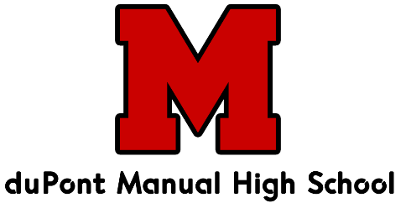
Crimson Clash
Presented by DuPont Manual High School and Ken Bowl Lanes
Saturday December 6th @ 9am
Entry $120 per team
Two individual 5-person games followed by 10 baker games
(Co-ed teams are allowed in the boys division)
Tournament Format/Rules
• Each school will have one 5-person team on one lane. Two games will be bowled on the same lane. The low score for each game will be dropped.
• Ten baker games will be bowled alternating lanes with the team on your pair only. Standard substitution rules apply.
• The top 4 teams (using total pins for the 18 games) for each division (boys/co-ed and girls) will go to a best 2 of 3 baker single elimination bracket to determine first and second place. In case of a tie after qualifying, the team with the high 10 game baker total will advance (then high baker game if still tied).
• All games will be bowled on the same pair.
• Lane assignments will be communicated the week of the tournament.
• Maximum roster size is 8.
• Space permitting, schools will be allowed multiple entries.
• Only coaches and bowlers are allowed in the pit area.

Please contact Ken Rowan by email (ken.rowan@att.net) or (text: 502-296-8323) with your entry information or any questions you might have.
Please make checks out to: Manual Bowling Booster Club
c/o Ken Rowan
10343 Arbor Oak Dr. Louisville, KY 40229

